Modbus Temperature Probe for Air, Gases and Liquids
The EE074 measures accurately the temperature of air, gases and liquids. The probe features a RS485 interface with Modbus RTU protocol.

(Engerwitzdorf, 23.10.2019) The EE074 from E+E Elektronik is suitable for accurate temperature measurement of air, gases and liquids. The robust stainless steel probe can be used for climate and process control in the food and pharmaceutical industries, in clean rooms or in agriculture.

The EE074 temperature probe offers a high measuring accuracy of ±0.1 °C and a wide measuring range of up to -70...105 °C (-94... 221 °F). The IP68 stainless steel enclosure and the fully encapsulated electronics lead to an excellent measuring performance and a longer lifetime even in harsh and condensing environment. The RS485 interface with Modbus RTU protocol facilitates the design-in of the probe.

Immersion Well for Measurement in Liquids
With the optionally available immersion well, the EE074 can be used for temperature measurement in pressurized liquids up to 25 bar (363 psi). The innovative clamp ring allows for fastening the probe in the immersion well without screws and thus without tools. The sensing head with 6 mm diameter is also compatible with other standard immersion wells.

Easy Installation
Various probe and cable lengths make the EE074 a flexible and versatile temperature probe. The M12x1 connector and the choice of optionally mounting accessories minimize installation time and costs.

Configuration, Adjustment and Calibration
An optional adapter and the free configuration software facilitate the setup and adjustment of the EE074.

Due to its mechanical design, the probe can be calibrated in a dry-block or liquid bath calibrator.

Characters (incl. spaces): 1730
Words: 267

Images:
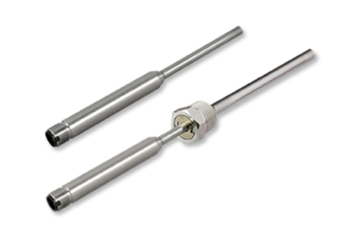
EE074 temperature probe from E+E Elektronik with and without immersion well.

Photos: E+E Elektronik GmbH, reprint free of charge

Company Profile
E+E Elektronik develops and manufactures sensors and transmitters for humidity, temperature, dew point, moisture in oil, air velocity, flow, CO₂ and pressure. Data loggers, hand-held measuring devices and calibration systems complete the comprehensive product portfolio of the Austrian sensor specialist. The main applications for E+E products lie in HVAC, building automation, industrial process control and the automotive industry. A certified quality management system according to ISO 9001 and IATF 16949 ensures the highest quality standards. E+E Elektronik has a worldwide dealership network and representative offices in Germany, France, Italy, Korea, China and the United States. The accredited E+E calibration laboratory has been commissioned by the Austrian Federal Office for Metrology (BEV) to provide the national standards for humidity and air velocity.

E+E Elektronik Ges.m.b.H.
Langwiesen 7
4209 Engerwitzdorf
Austria
T: +43 (0) 7235 605-0
F: +43 (0) 7235 605-8
info@epluse.at
www.epluse.com

Press contact:
Mr. Johannes Fraundorfer
T: +43 (0)7235 605-217
pr@epluse.at

