Intrinsically Safe Humidity and Temperature Sensor for Gas Explosion Hazard Areas
The new EE100Ex sensor is ATEX and IECEx approved for gas applications in explosion hazard areas up to zone 1.

(Engerwitzdorf, 14.08.2019) The new intrinsically safe EE100Ex from E+E Elektronik is certified according to the European ATEX directive 2014/34/EU and the international IECEx standards for use in gas explosion hazard areas up to zone 1. The humidity and temperature sensor offers high measuring accuracy and is dedicated for demanding climate and process control.

The EE100Ex complies with temperature class T4 for intrinsically safe equipment and can be mounted directly in hazardous area. Due to the robust IP65 aluminum enclosure and the wide choice of filter caps, the sensor is suitable for various applications such as utility tunnels, hazardous storage rooms or in the pharmaceutical industry.

Excellent Measuring Performance
The sensor enables highly accurate measurement of relative humidity [RH] and temperature [T] in the range 0...100 % RH and -40...60 °C (-40...140 °F). The combination of robust sensing head, proprietary E+E sensor coating and encapsulated measurement electronics inside the probe ensures excellent measuring performance and long-term stability in harsh and corrosive environment.

Configurable Analogue Outputs
The EE100Ex features two galvanically isolated, configurable 4…20 mA, 2-wire outputs. Besides RH and T, the sensor also calculates the dew point [Td] and frost point temperature [Tf].

User Friendly Operation
The device can be powered by any appropriate intrinsically safe power source or via Zener barriers. An error indication at the analogue outputs according to the NAMUR standard facilitates troubleshooting in case of a malfunction.

Characters (incl. spaces): 1767
Words: 261

Images:
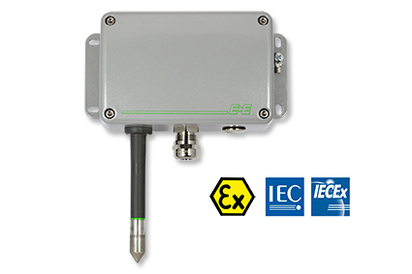
EE100Ex humidity and temperature sensor for gas hazardous areas.

Photos: E+E Elektronik GmbH, reprint free of charge

Company Profile
E+E Elektronik develops and manufactures sensors and transmitters for humidity, temperature, dew point, moisture in oil, air velocity, flow, CO₂ and pressure. Data loggers, hand-held measuring devices and calibration systems complete the comprehensive product portfolio of the Austrian sensor specialist. The main applications for E+E products lie in HVAC, building automation, industrial process control and the automotive industry. A certified quality management system according to ISO 9001 and IATF 16949 ensures the highest quality standards. E+E Elektronik has a worldwide dealership network and representative offices in Germany, France, Italy, Korea, China and the United States. The accredited E+E calibration laboratory has been commissioned by the Austrian Federal Office for Metrology (BEV) to provide the national standards for humidity and air velocity.

E+E Elektronik Ges.m.b.H.
Langwiesen 7
4209 Engerwitzdorf
Austria
T: +43 (0) 7235 605-0
F: +43 (0) 7235 605-8
info@epluse.at
www.epluse.com

Press contact:
Mr. Johannes Fraundorfer
T: +43 (0)7235 605-217
pr@epluse.at

