Modbus and BACnet Temperature Sensors for Building Automation
The temperature sensors from E+E Elektronik now also feature RS485 interface and can therefore be easily integrated into a network.

(Engerwitzdorf, 13.03.2019) The temperature sensors of the Austrian sensor manufacturer E+E Elektronik are now available with RS485 interface. The Modbus RTU and BACnet MS/TP protocols facilitate the integration into a bus system. The installation-friendly, IP65 / NEMA 4 enclosure is ideal for heating, ventilation and air conditioning systems.

The highly accurate and reliable E+E temperature sensors are optimized for building automation. The product range includes duct or immersion sensors (EE431) for temperature measurement in air and liquids, strap-on sensors (EE441) for mounting on ducts and pipes, wall mount sensors for indoors and outdoors (EE451) and temperature sensors with remote probe (EE471).

Easy Mounting, High Protection Class
The clever enclosure design allows for easy and fast installation. Thanks to the external mounting holes, the sensors can be mounted with closed cover. This saves time and protects the electronics from construction site contamination and mechanical damage. Due to the high protection class IP65 / NEMA 4 the temperature sensors are appropriate also for harsh environment.

Active and Passive Temperature Measurement
The E+E temperature sensors are available with active or passive output. The active sensors are fully user configurable and adjustable. They feature current or voltage output or RS485 interface with Modbus RTU or BACnet protocol. The passive sensors offer a wide choice of temperature sensing elements, such as Pt1000, NTC10k or Ni1000.

Comprehensive HVAC Portfolio
In addition to temperature sensors, E+E Elektronik’s HVAC product range includes sensors for relative humidity, CO₂, air velocity and differential pressure. Thus, the company offers all relevant measurands for building automation.

Characters (incl. spaces): 1945
Words: 282

Images:
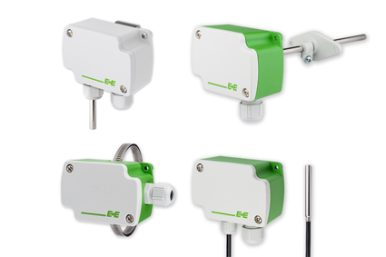
The temperature sensors EE431, EE441, EE451 and EE471 are now available with RS485 interface with Modbus or BACnet-protocol.

Photos: E+E Elektronik GmbH, reprint free of charge

E+E Elektronik develops and manufactures sensors and transmitters for humidity, temperature, dew point, moisture in oil, air velocity, flow, CO₂ and pressure. Data loggers, hand-held measuring devices and calibration systems complete the comprehensive product portfolio of the Austrian sensor specialist. The main applications for E+E products lie in HVAC, building automation, industrial process control and the automotive industry. A certified quality management system according to ISO 9001 and IATF 16949 ensures the highest quality standards. E+E Elektronik has a worldwide dealership network and representative offices in Germany, France, Italy, Korea, China and the United States. The accredited E+E calibration laboratory (OEKD) has been commissioned by the Austrian Federal Office for Metrology (BEV) to provide the national standards for humidity and air velocity.

E+E Elektronik Ges.m.b.H
Langwiesen 7
4209 Engerwitzdorf
Austria
T: +43 (0) 7235 605-0
F: +43 (0) 7235 605-8
info@epluse.at
www.epluse.com

Press contact:
Mr. Johannes Fraundorfer
T: +43 (0)7235 605-217
pr@epluse.at

