Differential Pressure Sensor with ±0.5 % Accuracy
The EE600 HVAC differential pressure sensor offers a high accuracy of ±0.5 % of the full scale and features four selectable pressure measuring ranges.

(Engerwitzdorf, 25.09.2019) The EE600 from E+E Elektronik measures the differential pressure in the range 0...1000 Pa or 0...10 000 Pa with an accuracy of ±0.5 % of the full scale. The sensor is dedicated for HVAC applications and can be employed for air and all non-flammable and non-aggressive gases.

The EE600 is ideal for reliable differential pressure measurement in ventilation and air conditioning systems or for filter monitoring. The sensor is available in two versions for up to 1000 Pa or 10 000 Pa. Four different measuring ranges (0…250 / 500 / 750 / 1000 Pa or 0…2500 / 5000 / 7500 / 10 000 Pa) are selectable via DIP switches. The piezo-resistive, no flow-through pressure sensing element stands for outstanding long-term stability.

Analogue Output and Display
The measured data is available as voltage and current signals at the spring loaded terminals. The large, backlit graphic display shows the reading in [Pa], [mbar], [inch WC] or [kPa].

Functional and Robust Enclosure
The robust IP65 / NEMA 4 enclosure with external mounting holes facilitates mounting the sensor with closed cover. This saves time and also protects the electronics from pollution and mechanical damage during installation. For US requirements, the enclosure features a knockout for a ½”conduit fitting.

Fully Configurable
The EE600 offers various adjustment and configuration options. Via DIP switches on the electronics board, the user can set the pressure measuring ranges, the output signal, the response time as well as the units and the backlight for the display. Also a zero and span point adjustment can be easily performed with push buttons.

Characters (incl. spaces): 1835
Words: 293

Images:
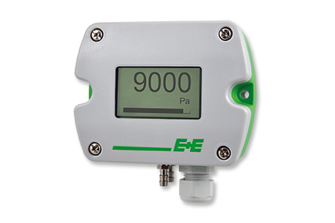
EE600 differential pressure sensor with ±0.5 % accuracy.

Photos: E+E Elektronik GmbH, reprint free of charge

Company Profile
E+E Elektronik develops and manufactures sensors and transmitters for humidity, temperature, dew point, moisture in oil, air velocity, flow, CO₂ and pressure. Data loggers, hand-held measuring devices and calibration systems complete the comprehensive product portfolio of the Austrian sensor specialist. The main applications for E+E products lie in HVAC, building automation, industrial process control and the automotive industry. A certified quality management system according to ISO 9001 and IATF 16949 ensures the highest quality standards. E+E Elektronik has a worldwide dealership network and representative offices in Germany, France, Italy, Korea, China and the United States. The accredited E+E calibration laboratory has been commissioned by the Austrian Federal Office for Metrology (BEV) to provide the national standards for humidity and air velocity.

E+E Elektronik Ges.m.b.H.
Langwiesen 7
4209 Engerwitzdorf
Austria
T: +43 (0) 7235 605-0
F: +43 (0) 7235 605-8
info@epluse.at
www.epluse.com

Press contact:
Mr. Johannes Fraundorfer
T: +43 (0)7235 605-217
pr@epluse.at

