Highly Accurate Low Differential Pressure Sensor
The EE610 is ideal for reliable and precise measurement of low differential pressure. It features selectable ranges for ±25, ±50, ±100 and 0...100 Pa.

(Engerwitzdorf, 25.6.2019) With the EE610, E+E Elektronik offers a new sensor for low differential pressure up to ±100 Pa with an accuracy of ±0.5 Pa. Due to selectable measuring ranges and versatile configuration options, the EE610 is suitable for a variety of applications in air as well as in non-flammable and non-aggressive gases.

The EE610 is dedicated for medical, pharmaceutical and clean room applications. For instance, the sensor can measure the differential pressure between clean rooms, surgery rooms or isolation chambers. The non-flow through design excludes cross-contamination.

Selectable Measuring Ranges
The EE610 enables unidirectional or bidirectional differential pressure measurement within a selectable measuring range of 0...100 Pa or ±25, ±50 and ±100 Pa. The long-term stable, piezo-resistive pressure sensing element provides a high accuracy of ±0.5 Pa

Analogue Output and Display
The measured data is simultaneously available as current and voltage signals at the spring loaded terminals. The illuminated graphic display shows the reading in Pa, mbar, inch water column or mm H₂O.

Fully Configurable
The EE610 can be easily configured on site. Pressure range, time constant, output signal, display units and backlight can be set via DIP switches on the electronics board. The zero and span point adjustment can be performed with push buttons.

Easy Mounting
The functional IP65 / NEMA 4 enclosure facilitates mounting the sensor with closed cover. This saves time and also protects the electronics from construction site pollution and mechanical damage during installation. For wiring the EE610 features both a cable gland and a knockout opening for a ½”conduit adapter.

Characters (incl. spaces): 1889
Words: 285

Images:
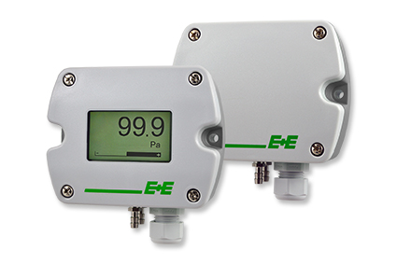
EE610 differential pressure sensor for low pressure.

Photos: E+E Elektronik GmbH, reprint free of charge

Company Profile
E+E Elektronik develops and manufactures sensors and transmitters for humidity, temperature, dew point, moisture in oil, air velocity, flow, CO₂ and pressure. Data loggers, hand-held measuring devices and calibration systems complete the comprehensive product portfolio of the Austrian sensor specialist. The main applications for E+E products lie in HVAC, building automation, industrial process control and the automotive industry. A certified quality management system according to ISO 9001 and IATF 16949 ensures the highest quality standards. E+E Elektronik has a worldwide dealership network and representative offices in Germany, France, Italy, Korea, China and the United States. The accredited E+E calibration laboratory has been commissioned by the Austrian Federal Office for Metrology (BEV) to provide the national standards for humidity and air velocity.

E+E Elektronik Ges.m.b.H.
Langwiesen 7
4209 Engerwitzdorf
Austria
T: +43 (0) 7235 605-0
F: +43 (0) 7235 605-8
info@epluse.at
www.epluse.com

Press contact:
Mr. Johannes Fraundorfer
T: +43 (0)7235 605-217
pr@epluse.at

