Robust CO₂ Sensor with RS485 Interface
The EE820 CO₂ sensor, particularly resistant to pollution, is now available also with digital interface.

(Engerwitzdorf, 18.4.2019) The well proven EE820 sensor from E+E Elektronik is appropriate for reliable monitoring the CO₂ concentration in harsh and polluted applications such as agriculture and life stock barns. Beside voltage and current output, the sensor is now also available with RS485 interface with Modbus RTU or BACnet MS/TP protocol.

Long-Term Stable CO₂ Measurement
The operation of the EE820 is based on the long-term stable E+E dual-wavelength NDIR principle, which is highly insensitive to contamination and automatically compensates for ageing effects. The multi-point CO₂ and temperature factory adjustment procedure ensures high CO₂ measurement accuracy over the entire temperature range -20…60 °C (-4…140 °F).

Suitable for Demanding Applications
The EE820 features a robust IP54 enclosure with a special filter, which offers best protection of the measurement electronics in harsh and polluted environment.

The functional enclosure facilitates mounting the sensor with closed cover. Thus, the electronics is safe from mechanical damage and construction site pollution during installation.

Fast Response Time due to Active Ventilation
For fast response time to changes in CO₂, the EE820 is optionally available with a forced air circulation module installed behind the filter.

Analogue Output, Modbus RTU and BACnet MS/TP
The measured data with range up to 10000 ppm CO₂ is available on the analogue output (voltage / current) or on the RS485 interface with Modbus RTU or BACnet MS/TP protocol.

An optional adapter and the free EE-PCS Product Configuration Software facilitate the configuration and adjustment of the EE820.

Characters (incl. spaces): 1778
Words: 263

Images:
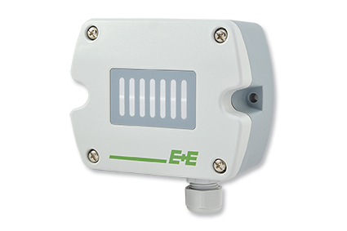
The EE820 CO₂ sensor from E+E Elektronik can be used in harsh environment.

Photos: E+E Elektronik GmbH, reprint free of charge

Company Profile
E+E Elektronik develops and manufactures sensors and transmitters for humidity, temperature, dew point, moisture in oil, air velocity, flow, CO₂ and pressure. Data loggers, hand-held measuring devices and calibration systems complete the comprehensive product portfolio of the Austrian sensor specialist. The main applications for E+E products lie in HVAC, building automation, industrial process control and the automotive industry. A certified quality management system according to ISO 9001 and IATF 16949 ensures the highest quality standards. E+E Elektronik has a worldwide dealership network and representative offices in Germany, France, Italy, Korea, China and the United States. The accredited E+E calibration laboratory has been commissioned by the Austrian Federal Office for Metrology (BEV) to provide the national standards for humidity and air velocity.

E+E Elektronik Ges.m.b.H.
Langwiesen 7
4209 Engerwitzdorf
Austria
T: +43 (0) 7235 605-0
F: +43 (0) 7235 605-8
info@epluse.at
www.epluse.com

Press contact:
Mr. Johannes Fraundorfer
T: +43 (0)7235 605-217
pr@epluse.at

