Digital CO₂, Humidity and Temperature Sensor
The EE850 sensor for CO₂, humidity and temperature features now RS485 interface with Modbus or BACnet protocol.

(Engerwitzdorf, 16.01.2019) The EE850 duct mount sensor from E+E Elektronik combines the CO₂, relative humidity (RH) and temperature (T) measurement in a single device. The sensor can be easily integrated into a bus system via the RS485 interface (Modbus RTU or BACnet MS/TP). The 3-in-1 device is dedicated for building automation as well as for demanding process control.

The EE850 features the E+E dual wavelength NDIR CO₂ sensing cell, which is particularly insensitive to contamination. The CO₂ auto-calibration and temperature compensation lead to high accuracy and long-term stability over the entire working range of 0…10,000 ppm CO₂ and -20 °C to +60 °C (-4...140 °F).

The RH and T sensing element located inside the probe is optimally protected from dust, dirt and corrosion by the proprietary E+E coating. The coating improves the measurement performance and long-term stability in harsh environment by preventing stray impedances caused by deposits on the active sensor surface.

The CO₂, RH and T measured data as well as the calculated dew point temperature (Td) are available on the RS485 interface with Modbus RTU or BACnet MS/TP protocol. Alternatively, the EE850 features current and voltage outputs. The digital interface provides also other parameters such as absolute humidity (dv), mixing ratio (r), water vapor partial pressure (e) or enthalpy (h).

Configuration and adjustment can be performed with an optional adapter and the free EE-PCS configuration software.

The functional enclosure facilitates mounting the EE850 with closed cover. This protects the electronics from construction site pollution during installation. A mounting flange is included in the scope of supply.

Characters (incl. spaces): 1849
Words: 281

Images:
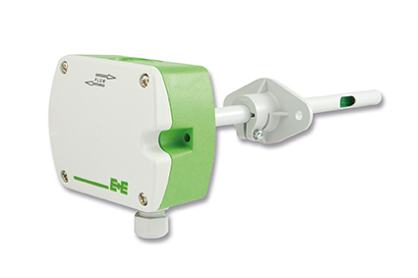
Digital EE850 transmitter for CO₂, humidity and temperature from E+E Elektronik.

Photos: E+E Elektronik GmbH, reprint free of charge

E+E Elektronik develops and manufactures sensors and transmitters for humidity, temperature, dew point, moisture in oil, air velocity, flow, CO₂ and pressure. Data loggers, hand-held measuring devices and calibration systems complete the comprehensive product portfolio of the Austrian sensor specialist. The main applications for E+E products lie in HVAC, building automation, industrial process control and the automotive industry. A certified quality management system according to ISO 9001 and IATF 16949 ensures the highest quality standards. E+E Elektronik has a worldwide dealership network and representative offices in Germany, France, Italy, Korea, China and the United States. The accredited E+E calibration laboratory (OEKD) has been commissioned by the Austrian Federal Office for Metrology (BEV) to provide the national standards for humidity and air velocity.

E+E Elektronik Ges.m.b.H
Langwiesen 7
4209 Engerwitzdorf
Austria
T: +43 (0) 7235 605-0
F: +43 (0) 7235 605-8
info@epluse.at
www.epluse.com

Press contact:
Mr. Johannes Fraundorfer
T: +43 (0)7235 605-217
pr@epluse.at

