Heated CO₂ Probe with Replaceable Sensing Module
EE872 is a highly accurate CO₂ probe for demanding applications. The heated CO₂ sensing module improves the measurement performance at high humidity.

(Engerwitzdorf, 3.4.2019) E+E Elektronik’s new EE872 CO₂ probe measures CO₂ concentration up to 5 % (50000 ppm) and features active pressure and temperature compensation with on-board sensors. The heated, replaceable CO₂ sensing module and the long-term stable dual wavelength NDIR operation principle lead to outstanding measurement performance even under harsh and condensing conditions.

Accurate and Long-Term Stable
With its temperature range -40...60 °C (-40…140 °F), the EE872 is appropriate for most CO₂ monitoring applications. The multi-point CO₂ and temperature adjustment ensures best accuracy over the entire working range. The probe incorporates the E+E dual-wavelength NDIR CO₂ sensor, which is highly insensitive to pollution. Due to auto-calibration, the sensor also shows excellent long-term stability.

Pressure and Temperature Compensation
On-board sensors compensate the effect of temperature, altitude or weather changes on the CO₂ measurement. This leads to highly accurate CO₂ reading independently of the environmental conditions.

Heated, Interchangeable CO₂ Sensing Module
The heating prevents condensation inside the sensing head. Thus, the EE872 is appropriate for use in in high humidity and condensing environment. The modular design facilitates the replacement of the interchangeable, pluggable sensing module.

Robust and Well Protected
The robust IP65 stainless steel or plastic enclosure and the replaceable PTFE filter cap provide optimum protection against contamination. With a special catalytic filter, the CO₂ probe is suitable for applications with periodic H₂O₂ sterilization.

Analogue or Digital
The EE872 provides the CO₂ measured data simultaneously on current and voltage outputs or via RS485 interface with Modbus RTU protocol.

Configuration and adjustment can be performed comfortably with the free configuration software and an optional adapter cable.

Characters (incl. spaces): 2085
Words: 292

Images:
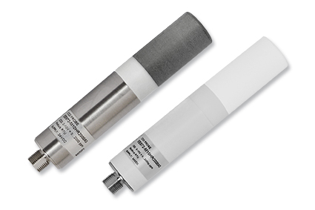
EE872 CO₂ probe with stainless steel or plastic enclosure

Photos: E+E Elektronik GmbH, reprint free of charge

Company Profile
E+E Elektronik develops and manufactures sensors and transmitters for humidity, temperature, dew point, moisture in oil, air velocity, flow, CO₂ and pressure. Data loggers, hand-held measuring devices and calibration systems complete the comprehensive product portfolio of the Austrian sensor specialist. The main applications for E+E products lie in HVAC, building automation, industrial process control and the automotive industry. A certified quality management system according to ISO 9001 and IATF 16949 ensures the highest quality standards. E+E Elektronik has a worldwide dealership network and representative offices in Germany, France, Italy, Korea, China and the United States. The accredited E+E calibration laboratory has been commissioned by the Austrian Federal Office for Metrology (BEV) to provide the national standards for humidity and air velocity.

E+E Elektronik Ges.m.b.H.
Langwiesen 7
4209 Engerwitzdorf
Austria
T: +43 (0) 7235 605-0
F: +43 (0) 7235 605-8
info@epluse.at
www.epluse.com

Press contact:
Mr. Johannes Fraundorfer
T: +43 (0)7235 605-217
pr@epluse.at

