New CO₂ Sensor for Railway Applications
The EE8915 complies with the relevant railway standards. The CO₂ sensor automatically compensates for temperature and pressure effects.

(Engerwitzdorf, 12.02.2019) The EE8915 from E+E Elektronik meets all relevant railway standards for reliable CO₂ measurement in railway vehicles, e.g. in the passenger compartment or driver's cab. On-board sensors ensure high CO₂ measurement accuracy independently of temperature, altitude or weather conditions. Due to excellent measurement performance in harsh environment, the sensor is also suitable for demanding process and climate control.

Long-Term Stable CO₂ Measurement
The E+E NDIR dual wavelength infrared measuring principle is particularly insensitive to contamination and automatically compensates for ageing effects. The EE8915 thus offers excellent long-term stability even under harsh conditions. The multi-point CO₂ and temperature factory adjustment ensures high measuring accuracy over the entire temperature range from -40 °C to +60 °C (-40…+140 °F).

High Protection Class and Short Response Time
Due to its innovative design, the CO₂ sensor offers a unique combination of short response time and high protection class IP65 / NEMA 4.

Active Pressure and Temperature Compensation
On-board sensors allow for active temperature and pressure compensation. The EE8915 therefore provides accurate CO₂ readings even under changing environmental conditions.

Versatile and Configurable
The CO₂ measured data in the range 0...2000 / 5000 / 10000 ppm is simultaneously available as current and voltage output. The USB service interface facilitates the configuration and adjustment.

Easy Mounting
The EE8915 is available for wall or duct mount, with M12 connector or fixed cable. The robust polycarbonate enclosure remains closed during installation, which optimally protects the electronics.

Characters (incl. spaces): 1868
Words: 262

Images:

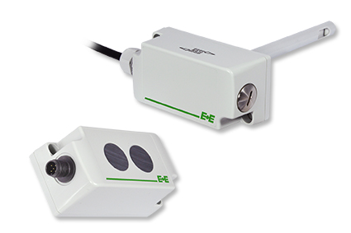
EE8915 CO₂ sensor for railway applications.

Photos: E+E Elektronik GmbH, reprint free of charge

E+E Elektronik develops and manufactures sensors and transmitters for humidity, temperature, dew point, moisture in oil, air velocity, flow, CO₂ and pressure. Data loggers, hand-held measuring devices and calibration systems complete the comprehensive product portfolio of the Austrian sensor specialist. The main applications for E+E products lie in HVAC, building automation, industrial process control and the automotive industry. A certified quality management system according to ISO 9001 and IATF 16949 ensures the highest quality standards. E+E Elektronik has a worldwide dealership network and representative offices in Germany, France, Italy, Korea, China and the United States. The accredited E+E calibration laboratory (OEKD) has been commissioned by the Austrian Federal Office for Metrology (BEV) to provide the national standards for humidity and air velocity.

E+E Elektronik Ges.m.b.H
Langwiesen 7
4209 Engerwitzdorf
Austria
T: +43 (0) 7235 605-0
F: +43 (0) 7235 605-8
info@epluse.at
www.epluse.com

Press contact:
Mr. Johannes Fraundorfer
T: +43 (0)7235 605-217
pr@epluse.at

