Highly Accurate Mass Flow and Dew Point Sensors for Compressed Air Monitoring
The flow meters and dew point sensors from E+E Elektronik make an important contribution to a cost-efficient and safe use of compressed air.

(Engerwitzdorf, 20.03.2019) Thermal flow meters from E+E Elektronik accurately measure the compressed air consumption in pipes from DN15 to DN700. They are suitable for leak detection and thus contribute relevantly to cost reduction. High-precision E+E sensors monitor the dew point temperature and the risk of condensation in the compressed air network. This leads to safe operation and maximizes the lifetime of tools and machines.

The flow meters of the Austrian sensor specialist are based on the thermal anemometer principle. They measure the mass flow or standard volumetric flow of compressed air and non-corrosive and non-flammable gases. All E+E flow meters feature an integrated consumption meter and are available with analogue or digital outputs.

The devices employ E+E thin-film sensing elements, which stand out by high accuracy, excellent long-term stability, short response time and best resistance to contamination.

Each E+E flow meter undergoes a precise factory calibration at the typical working pressure in a compressed air network. The corresponding calibration certificate is included in the standard scope of supply.

EE741 Modular Flow Meter
The EE741 consists of the flow sensor and a stainless steel or aluminum gauge mounting block for DN15 (1/2”), DN20 (3/4”), DN25 (1”) or DN32 (1 1/4”), DN40 (1 1/2”), DN50 (2”). Once the gauge mounting block is built into the pipe, the sensor can be easily removed and installed without disassembling the pipework.

The optional LCD display shows the actual measured data as well as the total consumption. The entire device setup can be performed comfortably via display or the USB interface.

EE771 Flow Meter with Measurement Ball Valve
The EE771 is suitable for DN15 to DN50 pipes. The measurement ball valve facilitates the precise and reproducible positioning of the sensing head inside the pipe, as well as installation and removal of the sensor with only a short flow interruption. The electronics of the version with remote probe can be located up to 10 m from the measurement point.

EE772 Flow Meter with Hot Tap Valve
The EE772 can be employed in DN40 to DN80 pipes. The gauge mounting block with hot tap valve allows for installation and removal of the probe without interrupting the air or gas flow. A calibration of the sensor is thus possible at any time and without system downtime.

The gauge mounting block can also accommodate an additional dew point sensor, such as EE355 or EE371.

EE776 Insertion Flow Meter
The EE776 is dedicated for pipe diameters up to DN700. An optional ball valve enables the installation and removal of the probe without flow interruption. The patented non-return protection ensures safe handling and precise positioning of the probe.

The tapping sleeve allows for drilling into the pipe under pressure and for mounting the EE776 without disturbing the process and without welding work.

Dew Point Sensors for Compressed Air
The E+E Elektronik’s sensors measure dew point temperature down to -60 °C Td (-76 °F Td) with pressure rating up to 100 bar (1450 psi). They are ideal for monitoring compressed air or refrigeration dryers. The auto-calibration ensures a high measuring accuracy of ±2 °C Td over the entire measuring range.

The EE371 features freely configurable analogue outputs (current / voltage) and a LCD display. The swirling front-end allows for optimal positioning of the display and of the connection cable independently of the mounting location.

The EE355 dew point sensor provides an analogue 4-20 mA output and a Modbus RTU interface. The compact, robust stainless steel enclosure is suitable for harsh industrial environment.

Trade fair notice: E+E Elektronik will exhibit at ComVac in Hannover from 1 - 5 April 2019 in hall 26 / booth A42.

Characters (incl. spaces): 3971
Words: 637

Images:
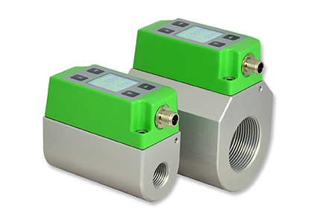  EE741 modular flow meters for DN15 to DN50. | 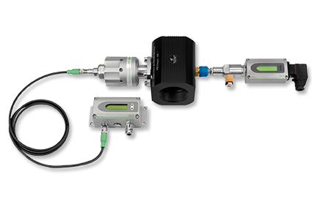  EE772 flow meter with hot tap valve and EE371 dew point sensor.
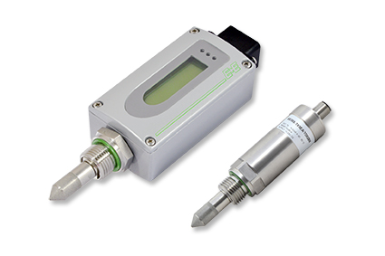
E+E dew point sensors EE371 and EE355.

Photos: E+E Elektronik GmbH, reprint free of charge

Company Profile
E+E Elektronik develops and manufactures sensors and transmitters for humidity, temperature, dew point, moisture in oil, air velocity, flow, CO₂ and pressure. Data loggers, hand-held measuring devices and calibration systems complete the comprehensive product portfolio of the Austrian sensor specialist. The main applications for E+E products lie in HVAC, building automation, industrial process control and the automotive industry. A certified quality management system according to ISO 9001 and IATF 16949 ensures the highest quality standards. E+E Elektronik has a worldwide dealership network and representative offices in Germany, France, Italy, Korea, China and the United States. The accredited E+E calibration laboratory (OEKD) has been commissioned by the Austrian Federal Office for Metrology (BEV) to provide the national standards for humidity and air velocity.

E+E Elektronik Ges.m.b.H.
Langwiesen 7
4209 Engerwitzdorf
Austria
T: +43 (0) 7235 605-0
F: +43 (0) 7235 605-8
info@epluse.at
www.epluse.com

Press contact:
Mr. Johannes Fraundorfer
T: +43 (0)7235 605-217
pr@epluse.at

