Humidity and Temperature Probe with Digital Interface
The EE072 is a highly accurate, versatile sensing probe. The robust probe can be easily integrated via Modbus RTU or CANopen.

(Engerwitzdorf, 18.08.2020) The EE072 by E+E Elektronik is a highly accurate humidity and temperature probe for demanding process and climate control tasks. The probe can be used for example in agriculture and livestock farming, the food and pharmaceutical industries or in clean rooms. The digital interface with the Modbus RTU or CANopen communication protocol facilitates the design-in of the EE072.

Versatile in Use and Highly Accurate
A wide temperature range of -40 to 80 °C (-40 to 76 °F), the robust IP65 stainless steel or polycarbonate enclosure and various filter caps make the EE072 a versatile sensing probe. The very good temperature compensation and configurable pressure compensation ensure high measuring accuracy of up to ±1.3 % RH and ±0.1 °C.

Long-Term Stability in Harsh Environments
The E+E Sensor-Coating protects the humidity sensing element against corrosive and electrically conductive contamination. This ensures excellent long-term stability even in harsh environments. In combination with the rugged sensing head and the encapsulated measuring electronics, the EE072 is ideally suited for particularly demanding measuring tasks.

Easy Integration Thanks to Industrial Standards
The digital sensing probe is available with an RS485 interface and the Modbus RTU protocol or a CAN interface with the CANopen protocol. The two standardised communication protocols allow the direct integration of the EE072 into the control systems commonly used in the industrial sector. In addition, the industry-standard M12x1 connecting plug allows for fast electrical system integration.

Calculation of Further Physical Quantities
The EE072 not only measures relative humidity and temperature, it also calculates all humidity related parameters, such as the dew point, frost point or wet bulb temperature, etc.
The sensing probe can be easily configured with the help of an optional adapter and the free configuration software.

Characters (incl. spaces): 2110
Words: 314

Images:
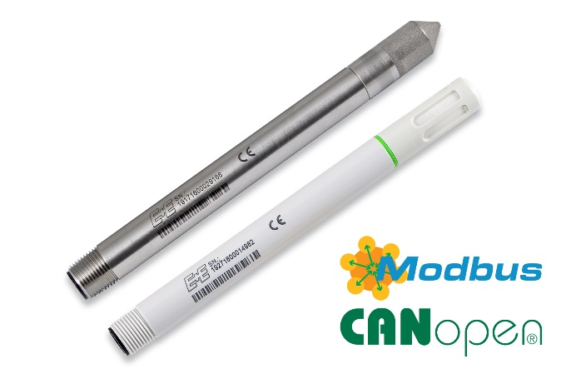
The EE072 humidity and temperature probe is available in stainless steel or polycarbonate.

Photos: E+E Elektronik Ges.m.b.H., reprint free of charge

Company Profile
E+E Elektronik develops and manufactures sensors and transmitters for humidity, dew point, moisture in oil, CO₂, air velocity, flow, temperature and pressure. Hand-held meters, humidity calibration systems and calibration services complete the comprehensive product portfolio of the Austrian sensor specialist. The main applications for E+E products lie in HVAC, building automation, industrial process control and the automotive industry. A certified quality management system according to ISO 9001 and IATF 16949 ensures the highest quality standards. E+E Elektronik is represented with own subsidiaries in China, Germany, France, Italy, Korea, USA and sales partners in more than 60 countries worldwide. The accredited E+E calibration laboratory has been commissioned by the Austrian Federal Office for Metrology (BEV) to provide the national standards for humidity and air velocity.

E+E Elektronik Ges.m.b.H.
Langwiesen 7
4209 Engerwitzdorf
Austria
T: +43 (0) 7235 605-0
F: +43 (0) 7235 605-8
info@epluse.at
www.epluse.com

Press contact:
Mr. Johannes Fraundorfer
T: +43 (0)7235 605-217
pr@epluse.at

