Heated Humidity and Temperature Probe for Meteorology
The new EE260 sensing probe has a dual heating system to deliver precise and reliable measuring results even at high levels of humidity.

(Engerwitzdorf, 1.9.2020) The EE260 humidity and temperature probe is the latest product development for meteorology from E+E Elektronik. Among other applications, this high-precision sensing probe is perfect for reliable weather monitoring in road traffic or at airports. The sensor and probe heating enables precise and continuous humidity measurement even in areas with high humidity levels. Due to its compact design, the EE260 is compatible with commercially available radiation shields.

Precise and Continuous Measurement Despite High Humidity
The EE260 sensing probe has a dual heating system consisting of a sensor and probe heating. Heating prevents condensation of the humidity sensing element and measuring head in case of fog, dew, rain or snowfall. This means that the probe always delivers precise and reliable measuring results even where humidity levels are permanently high. Heating also results in a very short response time, making the EE260 particularly suitable for use in weather warning systems.

Long-term Stability Thanks to Sensor Coating
The monolithic humidity and temperature sensing element built into the measuring head is protected against corrosive and electrically conductive contamination by the proprietary E+E sensor coating. Especially near the sea (salt) or in a dusty environment, the long-term stability and service life of the sensor is significantly improved.

Compact, Innovative Design
In addition to the heated humidity sensing element, the EE260 has a separate temperature sensing element which is integrated into the probe in an innovative way. Due to its compact design, the sensing probe is compatible with commercially available rotationally symmetric radiation shields. The IP67 enclosure, made of UV- and heat-resistant thermoplastic elastomer, protects the internal electronics against environmental influences and mechanical damage in the best possible way.

Analogue and Digital Measured Value Output
The sensing probe has two freely configurable voltage outputs and an RS485 interface with Modbus RTU protocol. The measuring data is available simultaneously at the analogue outputs and at the digital output.

Based on the measured humidity and temperature values, the EE260 calculates further humidity-related quantities such as the dew point temperature, absolute humidity or mixing ratio.

Characters (incl. spaces): 2525
Words: 368

Images:
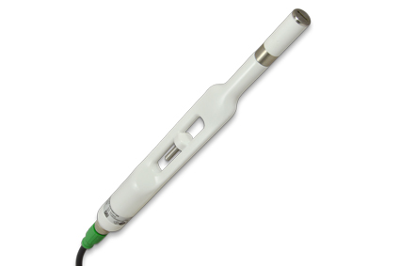
EE260 humidity and temperature probe for challenging meteorological applications.

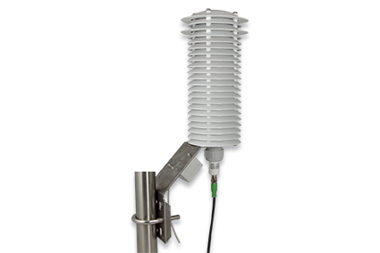
Due to its compact design, the EE260 is compatible with commercially available radiation shields.

Photos: E+E Elektronik Ges.m.b.H., reprint free of charge

Company Profile
E+E Elektronik develops and manufactures sensors and transmitters for humidity, dew point, moisture in oil, CO₂, air velocity, flow, temperature and pressure. Hand-held meters, humidity calibration systems and calibration services complete the comprehensive product portfolio of the Austrian sensor specialist. The main applications for E+E products lie in HVAC, building automation, industrial process control and the automotive industry. A certified quality management system according to ISO 9001 and IATF 16949 ensures the highest quality standards. E+E Elektronik is represented with own subsidiaries in China, Germany, France, Italy, Korea, USA and sales partners in more than 60 countries worldwide. The accredited E+E calibration laboratory has been commissioned by the Austrian Federal Office for Metrology (BEV) to provide the national standards for humidity, dew point and air velocity.

E+E Elektronik Ges.m.b.H.
Langwiesen 7
4209 Engerwitzdorf
Austria
T: +43 (0) 7235 605-0
F: +43 (0) 7235 605-8
info@epluse.at
www.epluse.com

Press contact:
Mr. Johannes Fraundorfer
T: +43 (0)7235 605-217
pr@epluse.at

