4 in 1 Probe Measures CO₂, Humidity, Temperature and Pressure
The EE872 is suitable for measuring CO₂, humidity, temperature and pressure in demanding environment and also for CO₂ measurement under high humidity.

(Engerwitzdorf, 12.03.2020) The EE872 from E+E Elektronik measures the CO₂ concentration up to 5 % (50 000 ppm) as well as relative humidity, temperature and ambient pressure. Additionally, the 4 in 1 probe also calculates the dew point temperature. It is perfectly suited for use in harsh and aggressive environment, such as agricultural applications. The active pressure and temperature compensation ensures a very high CO₂ measuring accuracy. A heated probe version is available for CO₂ measurement in high humidity applications.

For Harsh Environmental Conditions
The CO₂ measurement is based on the pollution-resistant E+E dual wavelength NDIR measuring principle. It automatically compensates for aging effects, which leads to outstanding long-term stability. Thanks to the E+E proprietary coating, the humidity sensing element is suitable even for aggressive and corrosive environment. The robust IP65 stainless steel or polycarbonate enclosure as well as various filter caps optimally protect the sensing module from contamination. The probe is therefore particularly suitable for use in agriculture, for example in life stock barns, hatchers, incubators and green houses.

High Measuring Accuracy
The multi-point CO₂ and temperature factory adjustment ensures high accuracy over the entire working range of -40...60 °C (-40…140 °F). Due to the active pressure and temperature compensation with on-board sensors, the EE872 offers a particularly high CO₂ measuring accuracy, independent of altitude or environmental conditions.

Heated Probe Version for High Humidity
The heated version of the EE872 can be used especially for CO₂ measurement in high humidity or condensing conditions. The heating prevents condensation on the sensing module, which makes the probe work reliably even in the high humidity range. Additionally to CO₂ and pressure, the heated version provides the dew point temperature.

Easy Service and Configuration
The EE872 has a modular design. The pluggable sensing module can be replaced in just a few seconds without requiring any tools. Also the filter caps (PTFE or catalytic for H₂O₂ sterilization) can be quickly replaced if necessary.

Configuration and adjustment of the EE872 can be easily performed with the free configuration software together with an optional adapter cable.

Analog or with RS485 interface
The CO₂ measured data is available simultaneously on the analogue voltage and current outputs. Depending on the version, the EE872 with RS485 interface also provides the data for relative humidity (RH), temperature (T), pressure (p) or dew point (Td).

Characters (incl. spaces): 2794
Words: 416

Images:
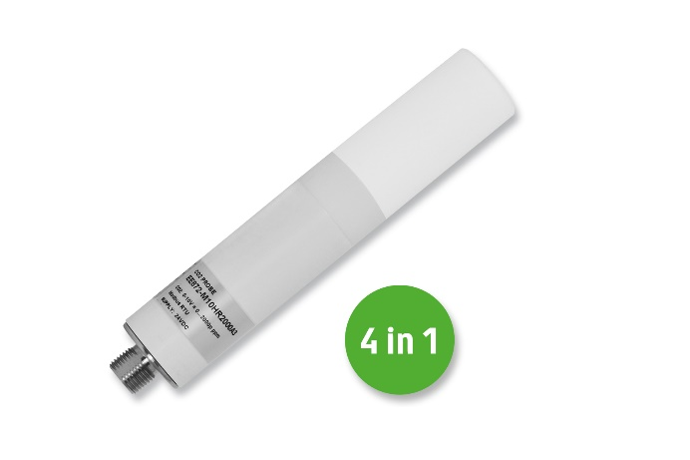
Besides CO₂, the EE872 from E+E Elektronik also measures relative humidity, temperature and ambient pressure.

Photos: E+E Elektronik GmbH, reprint free of charge

Company Profile
E+E Elektronik develops and manufactures sensors and transmitters for humidity, dew point, moisture in oil, CO₂, air velocity, mass flow, temperature and pressure. Hand-held meters, humidity calibration systems and calibration services complete the comprehensive product portfolio of the Austrian sensor specialist. The main applications for E+E products lie in HVAC, building automation, industrial process control and the automotive industry. A certified quality management system according to ISO 9001 and IATF 16949 ensures the highest quality standards. E+E Elektronik has subsidiaries in China, Germany, France, Italy, Korea and the USA and is represented by over 50 sales partners worldwide. The accredited E+E calibration laboratory has been commissioned by the Austrian Federal Office for Metrology (BEV) to provide the national standards for humidity and air velocity.

E+E Elektronik Ges.m.b.H.
Langwiesen 7
4209 Engerwitzdorf
Austria
T: +43 (0) 7235 605-0
F: +43 (0) 7235 605-8
info@epluse.at
www.epluse.com

Press contact:
Mr. Johannes Fraundorfer
T: +43 (0)7235 605-217
pr@epluse.at

