Miniature Sensor Module Measures CO₂, Temperature and Pressure
The EE895 sensor module is ideal for use in climate measuring devices. Pressure and temperature compensation ensure a high CO₂ measuring accuracy.

(Engerwitzdorf, 23.09.2020) The new EE895 sensor module from E+E Elektronik measures CO₂, temperature and ambient pressure. The small 3-in-1 module is an ideal choice for measuring instruments used for ventilation and climate control, in building automation or for process control. Due to its low power consumption, the module is also suitable for battery-operated devices such as hand-held meters, data loggers or wireless transmitters. The temperature and pressure compensation ensures high CO₂ measurement accuracy under changing environmental conditions.

A Single Module – 3 Measurands
Additionally to CO₂ concentration up to 10 000 ppm the EE895 module measures also the temperature and ambient pressure. The pressure and temperature compensation with on-board sensors minimizes the environmental influences onto the CO₂ measurement. Thus the module offers a constantly high CO₂ measurement accuracy, independent of altitude or changing ambient conditions.

Long-Term Stable CO₂ Measurement Principle
The dual wavelength NDIR CO₂ measuring principle with auto-calibration ensures long-term stable measurements, as it automatically compensates for aging effects and is particularly resistant to contamination. The factory multi-point CO₂ and temperature adjustment procedure leads to an excellent CO₂ measurement accuracy over the entire temperature working range of -40...60 °C (-40...140 °F).

Easy Design-In
The measured data for CO₂, temperature and pressure is available on the I²C or UART interface. The very small dimensions of only 35 mm x 15 mm x 7 mm (1.38" x 0.6" x 0.27") and various mounting options facilitate the design-in of the sensor module.

Flexibly Configurable
The EE895 module can be flexibly configured via the digital interface. The CO₂ measurement interval can be set according to the application and the power requirements.

Evaluation Board for Testing on a PC
With the separately available EE895 Evaluation Board, the sensor module can be tested on a PC. The free evaluation software displays the measurement data in graphical form and allows the user to set the sampling rate and the measurement units for temperature and pressure. For further processing, the data can be saved as .CSV file.

Characters (incl. spaces): 2419
Words: 359

Images:

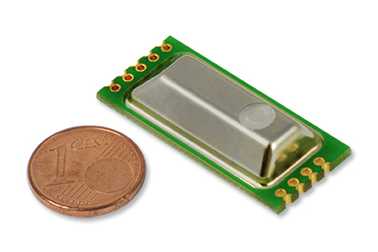
Fig. 1: EE895 sensor module for CO₂, temperature and pressure

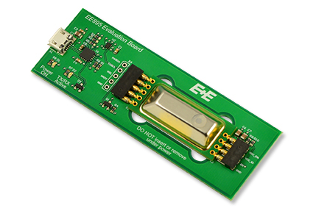
Fig. 2: The EE895 Evaluation Board facilitates testing of the sensor module on a PC

Photos: E+E Elektronik GmbH, reprint free of charge

Company Profile
E+E Elektronik develops and manufactures sensors and transmitters for humidity, dew point, moisture in oil, CO₂, air velocity, flow, temperature and pressure. Hand-held meters, humidity calibration systems and calibration services complete the comprehensive product portfolio of the Austrian sensor specialist. The main applications for E+E products lie in HVAC, building automation, industrial process control and the automotive industry. A certified quality management system according to ISO 9001 and IATF 16949 ensures the highest quality standards. E+E Elektronik is represented with own subsidiaries in China, Germany, France, Italy, Korea, USA and sales partners in more than 60 countries worldwide. The accredited E+E calibration laboratory has been commissioned by the Austrian Federal Office for Metrology (BEV) to provide the national standards for humidity, dew point and air velocity.

E+E Elektronik Ges.m.b.H.
Langwiesen 7
4209 Engerwitzdorf
Austria
T: +43 (0) 7235 605-0
F: +43 (0) 7235 605-8
info@epluse.at
www.epluse.com

Press contact:
Mr. Johannes Fraundorfer
T: +43 (0)7235 605-217
pr@epluse.at

