Measuring Instrument Calibration in the Accredited E+E Calibration Laboratory
Austrian sensor manufacturer E+E Elektronik's calibration laboratory offers accredited measuring instrument calibration according to EN ISO/IEC 17025.

(Engerwitzdorf, 22 04 2020) Austrian sensor manufacturer E+E Elektronik operates an EN ISO/IEC 17025 accredited calibration laboratory for humidity, dew point, CO₂, air velocity, mass flow, temperature and pressure at its headquarters in Engerwitzdorf. Accredited calibrations are needed wherever particularly high accuracy of the used measuring instruments is required. The calibration certificates issued confirm the traceability of the measured values to the national standard to comply with globally recognised standards.

Measuring equipment monitoring plays a central role in modern, automated production processes. If measuring instruments do not deliver the required accuracy, this endangers a smooth process flow, safety and also the quality of the end product. For this reason, regular calibration of the used measuring instruments is an essential part of most quality assurance systems.

Use Production Downtimes to Calibrate Measuring Instruments
"Due to the current corona pandemic, many companies have currently shut down or stopped production. This interruption can now be used to have the measuring instruments used in the production process checked and calibrated", recommends Thomas Blumhagel, Head of Sales and Marketing at E+E Elektronik. The accredited E+E Elektronik calibration laboratory offers an option to do so.

Calibration in the Accredited Laboratory
The calibration laboratory operated by E+E Elektronik GmbH is accredited by Akkreditierung Austria/Federal Ministry for Digital and Economic Affairs (Bundesministerium für Digitalisierung und Wirtschaftsstandort) according to EN ISO/IEC 17025 under the identification number 0608. The E+E Calibration Service includes manufacturer-independent measuring instrument calibrations for the measurands humidity, dew point, CO₂, air velocity, mass flow, temperature and pressure.

The decisive feature of an accredited calibration is the traceability of the measurement results to a national standard, as it takes into account the measurement uncertainties of the entire calibration process. In contrast to ISO or works calibration certificates, only accredited calibration certificates are internationally comparable.

Special Calibrations in the Designated Institute / NMI
Since 2004, the E+E calibration laboratory, as a Designated Institute of the Austrian Federal Office of Metrology and Surveying (Bundesamt für Eich- und Vermessungswesen – BEV), has provided the "National Etalon" (measurement standard) for air humidity. In 2011 the designation for air flow velocity was also assigned. The calibration experts in Engerwitzdorf are thus the highest metrological authority in the country for these two measured variables.

As a Designated Institute, the E+E calibration laboratory can carry out special calibrations for humidity and air flow velocity at the level of a National Metrological Institute (NMI). This is of particular interest for other accredited calibration laboratories, Designated Institutes or NMIs.

Especially for the calibration of high-precision dew point mirrors, the metrological capabilities of the Designated Institute are in demand internationally. "In Europe and even worldwide, only a handful of laboratories cover a comparable scope of calibration," says Dietmar Pachinger, head of the E+E Elektronik calibration laboratory.

Detailed information on the scope of accreditation and calibration services is available on the website: www.eplusecal.com.

Characters (incl. spaces): 3671
Words: 500

Images:

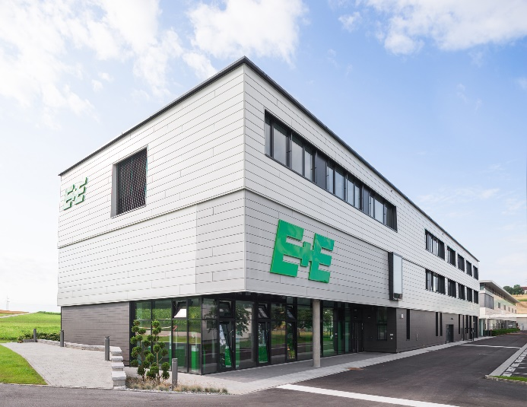
E+E Elektronik operates an EN ISO/IEC 17025 accredited calibration laboratory at its headquarters in Engerwitzdorf, Austria.

"Use production downtimes now to have measuring instruments calibrated", recommends Thomas Blumhagel, Head of Sales and Marketing at E+E Elektronik.

Photos: E+E Elektronik Ges.m.b.H., reproduction free of charge

Company profile
E+E Elektronik develops and manufactures sensors and transmitters for humidity, dew point, moisture in oil, CO₂, air velocity, mass flow, temperature and pressure. Hand-held meters, humidity calibration systems and calibration services complete the comprehensive product portfolio of the Austrian sensor specialist. The main applications for E+E products lie in HVAC, building automation, industrial process control and the automotive industry. A certified quality management system according to ISO 9001 and IATF 16949 ensures the highest quality standards. E+E Elektronik has subsidiaries in China, Germany, France, Italy, Korea and the USA and is represented by over 50 sales partners worldwide. The accredited E+E calibration laboratory has been commissioned by the Austrian Federal Office for Metrology (BEV) to provide the national standards for humidity and air velocity.

E+E Elektronik Ges.m.b.H.
Langwiesen 7
4209 Engerwitzdorf
Austria
T: +43 (0) 7235 605-0
F: +43 (0) 7235 605-8
info@epluse.at
www.epluse.com

Press contact:
Mr. Johannes Fraundorfer
T: +43 (0)7235 605-217
pr@epluse.at

