Humidity and Temperature Sensor with Interchangeable Sensing Module
The EE212 is designed for measurement tasks in a harsh and aggressive environment. If needed, the sensing module can be easily replaced.

(Engerwitzdorf, 12.05.2021) The EE212 humidity and temperature sensor by E+E Elektronik is suitable for challenging measurement tasks in climate technology, agriculture and the pharmaceuticals industry. Thanks to the modular probe design the sensing module can be easily replaced directly on site if needed. E+E sensor coating, the wide choice of filter caps, and the robust IP65 / NEMA 4 enclosure ensure accurate and reliable measurements even under challenging working conditions.

High-Quality, Interchangeable Sensing Module
The EE212's sensing head accommodates a sensing module with a latest generation high-precision E+E humidity and temperature sensing element. The E+E proprietary sensor coating and the sealed solder pads improve measuring performance, and extend the sensing elements life in harsh environment. The electronics inside the module is encapsulated and therefore best protected against condensation. A wide choice of different filter caps is available for the sensing probe.

One major benefit of the EE212 for use in a heavily polluted and aggressive environment is the modular probe design. It enables easy replacement of the sensing module with just a few steps and completely without tools. This means that downtime and service costs can be minimised.

Versatile Use, Easy Configuration
The EE212 can be flexibly adapted to the measurement task for versatile use. In addition to accurate measurement of the humidity and temperature, the sensor calculates various humidity-related parameters such as dew point temperature, absolute humidity and mixing ratio. The measured values are available on two configurable analogue outputs. Three other physical quantities can be displayed on the optional graphic display. Thanks to the free EE-PCS configuration software, the measurands assignments, output scaling and display can be adjusted.

Installation-Friendly Enclosure
A wall version and a duct version of the EE212 are available. The proven HVAC enclosure allows the sensor to be mounted with closed cover. This means that electronics are protected against construction site pollution. The enclosure screws with bayonet closures facilitate fast opening and closing of the cover to complete the electrical installation. For use in the US market, the enclosure features a knockout for a ½" conduit fitting.

Characters (incl. spaces): 2525
Words: 372

Images:
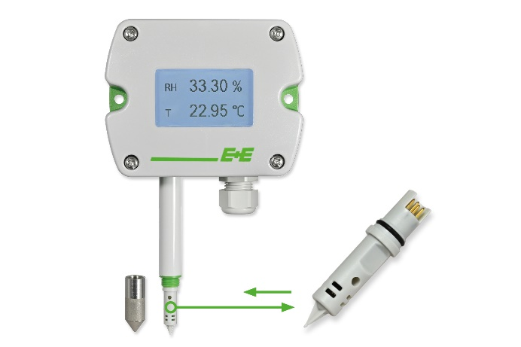
EE212 humidity and temperature sensor with interchangeable sensing module

Photos: E+E Elektronik Ges.m.b.H., reprint free of charge

Company Profile
E+E Elektronik develops and manufactures sensors and transmitters for humidity, dew point, moisture in oil, CO₂, air velocity, flow, temperature and pressure. Hand-held meters, humidity calibration systems and calibration services complete the comprehensive product portfolio of the Austrian sensor specialist. The main applications for E+E products lie in HVAC, building automation, industrial process control and the automotive industry. A certified quality management system according to ISO 9001 and IATF 16949 ensures the highest quality standards. E+E Elektronik is represented with own subsidiaries in China, Germany, France, Italy, Korea, USA and sales partners in more than 60 countries worldwide. The accredited E+E calibration laboratory has been commissioned by the Austrian Federal Office for Metrology (BEV) to provide the national standards for humidity, dew point, air velocity and gas concentration CO₂.

E+E Elektronik Ges.m.b.H.
Langwiesen 7
4209 Engerwitzdorf
Austria
T: +43 (0) 7235 605-0
F: +43 (0) 7235 605-8
info@epluse.com
www.epluse.com

Press contact:
Mr. Johannes Fraundorfer
T: +43 (0)7235 605-217
pr@epluse.at

