Air Velocity Sensor for Laminar Flow Monitoring
The EE680 by E+E Elektronik offers high measurement accuracy and is ideal for cleanroom applications due to its GMP-compliant design.

(Engerwitzdorf, 24.02.2021) The EE680 air velocity sensor by E+E Elektronik is used to monitor the laminar flow in cleanrooms or on safety workbenches. The sensor precisely measures the air velocity up to 2 m/s (400 ft/min) and simultaneously also the temperature. It meets the requirements of Good Manufacturing Practice (GMP) and is therefore ideally suited for the pharmaceuticals, biotechnology and microelectronics industries.

The flow sensing element used in the EE680 is based on the hot film anemometer principle and enables simultaneous measurement of air velocity and temperature. It provides accurate values from as low as 0.1 m/s (20 ft/min) and offers excellent long term stability and low angular dependence. The special E+E sensor coating makes the thin film sensing element highly resistant to H₂O₂ sterilisation and other aggressive cleaning agents.

High Measurement Accuracy
Factory multi-point adjustment of the air velocity ensures high measurement accuracy over the entire working range. An adjustment point at 0.45 m/s (88.6 ft/min) takes into account the air flow range defined in the EU GMP directive for the manufacture of sterile medical devices. The measurement accuracy of the sensor is confirmed by an inspection certificate in accordance with DIN EN 10204-3.1.

GMP-Compliant Design
With its smooth stainless steel enclosure and a sensor design optimised for laminar flow monitoring, the EE680 meets the requirements of Good Manufacturing Practice (GMP) in the cleanroom. The straight or angled design of the sensor with different probe lengths allows for wall or ceiling mounting at the ideal distance from the filter element, according to EN ISO 14644-3. The practical mounting flange and M12 stainless steel connector facilitate the installation and replacement of the EE680.

Visual Status Indication
An LED ring integrated into the enclosure indicates the laminar flow conditions and the sensor status. Any deviation from the target state or operating fault can therefore be quickly detected. The preset threshold values and further indication options can be configured individually.

Analogue or Digital Output
The measured values for air velocity and temperature are optionally available at the analogue voltage or current output, or at the RS485 interface via the Modbus RTU protocol. The type of measured value output can also be retroactively configured.

Configuring and adjusting the EE680 is a particularly user-friendly experience with the help of an optional adapter and the free configuration software.

Characters (incl. spaces): 2717
Words: 410

Images:
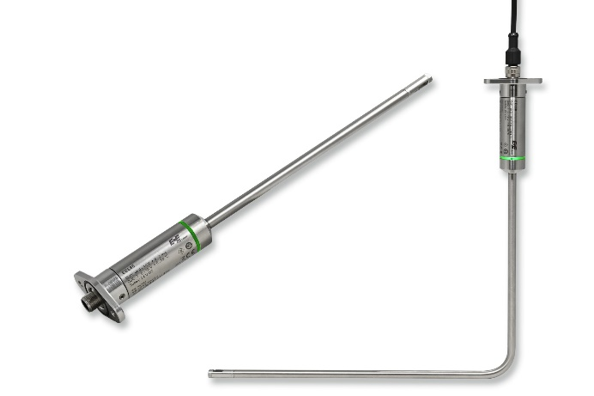

Straight or angled, the EE680 flow sensor is optimised for laminar flow monitoring in cleanrooms or safety workbenches.

Photos: E+E Elektronik Ges.m.b.H., printing free of charge

Enterprise profile
E+E Elektronik develops and produces sensors and transmitters for humidity, dew point, moisture in oil, CO₂, air velocity, flow, temperature and pressure. Handheld measuring instruments, humidity calibration systems and calibration services round off the extensive product portfolio of the Austrian sensor specialist. The main areas of application for E+E products are in HVAC and building technology, industrial measurement technology and the automotive industry. A certified quality management system according to ISO 9001 and IATF 16949 ensures the highest quality standards. E+E Elektronik is represented by its own subsidiaries in China, Germany, France, Italy, Korea, and the USA, and by sales partners in more than 60 countries worldwide. The E+E calibration laboratory, accredited by "Accreditation Austria", is commissioned by Austria's Federal Office of Metrology and Surveying (BEV) to provide the national standards for humidity, dew point and air flow velocity in Austria.

E+E Elektronik Ges.m.b.H.
Langwiesen 7
4209 Engerwitzdorf
Austria
T: +43 (0) 7235 605-0
F: +43 (0) 7235 605-8
info@epluse.com
www.epluse.com

Press contact:
Mr. Johannes Fraundorfer
T: +43 (0)7235 605-217
pr@epluse.at

