Press Release

E+E Elektronik: New Brand Identity – but the Promise Remains
(Engerwitzdorf, 23 November 2021) Curtain up for E+E Elektronik's new brand identity. From now on, the Austrian sensor manufacturer presents itself with a new corporate design. But the company is remaining true to its brand promise "your partner in sensor technology".
Innovative products, cooperative relationships and sustainable action – this is what E+E Elektronik has embodied for more than 40 years. Today, the Austrian sensor manufacturer is one of the world's leading suppliers of sensors for a wide range of measured variables. As a visible sign of its continuous development and advancing internationalisation, the company is now taking to the stage with a fresh corporate design.

Consice logo, clear message
While modernising the brand identity, care was taken to continue central key elements of the previous look. The new logo was reduced to its essential constituents. The familiar green "E+E" and the slogan "your partner in sensor technology" have been retained and shifted into the focus. With this core message, the company, which now has more than 400 employees, is underscoring its commitment to long-term partnerships with its customers, sales partners and suppliers.
"Our promise 'your partner in sensor technology', means that we focus on our customers, business partners and employees alike. We live a partnership at eye level," say the two managing directors Heinz Kindlhofer and Wolfgang Timelthaler.

Committed to the new look
The worldwide changeover of internal and external communication media and channels to the new image is being rolled out gradually and with a view to conserving resources. In addition to its headquarters in Engerwitzdorf, the company now has six subsidiaries around the globe. The aim of the new branding is to create a consistent, clear and internationally comprehensible brand image.
"Thanks to our new image, we can showcase ourselves in a state-of-the-art way, with clear lines and a high recognition value. Over the years, we have continued to develop and expand our global presence. Now is the right time for us to use our new corporate design to communicate our brand promise even more strongly to the outside world and make it more visible," says the board.

Images
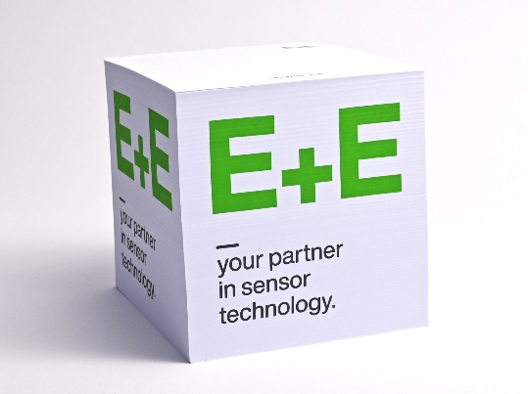
The well-known "E+E" and the brand promise "your partner in sensor technology" are still in focus of the new look

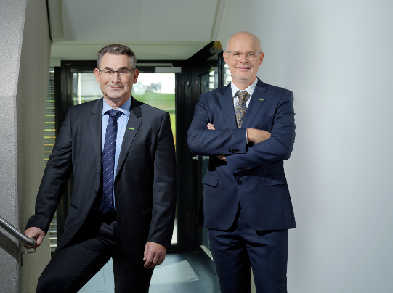
The two managing directors Heinz Kindlhofer and Wolfgang Timelthaler

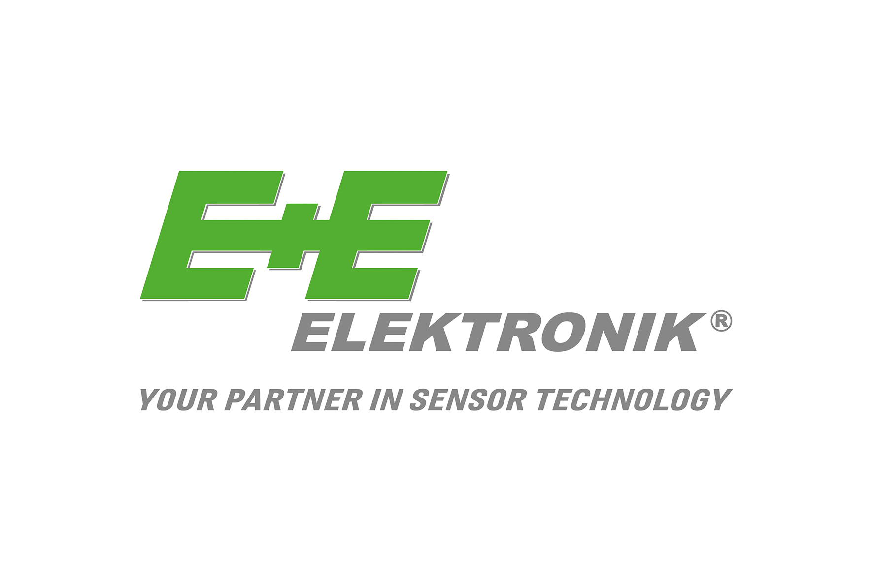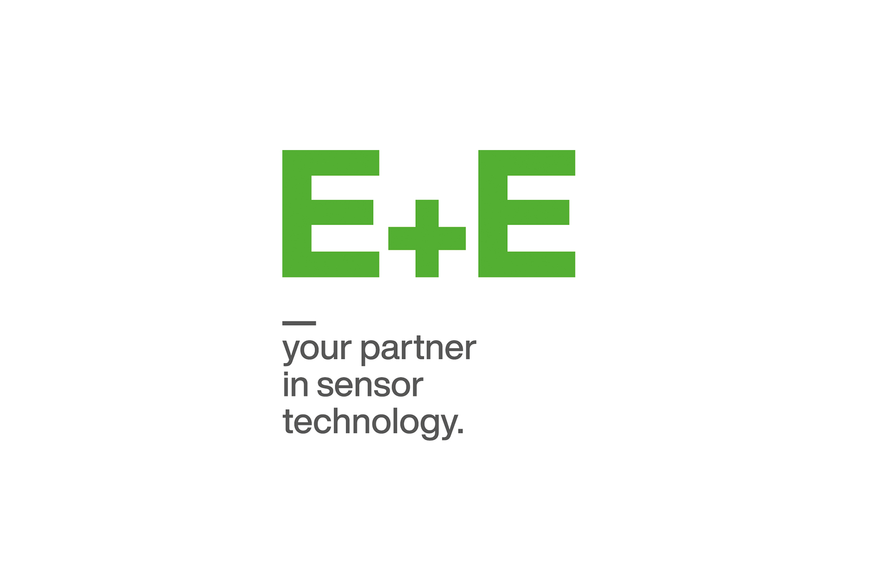
A comparison of the two logos. The old logo (left) has marked the brand identity of E+E Elektronik since 2003.

Photos: E+E Elektronik Ges.m.b.H., reprinting free of charge

Company Profile
E+E Elektronik develops and manufactures sensors and transmitters for humidity, dew point, moisture in oil, CO₂, air velocity, flow, temperature and pressure. Hand-held meters, humidity calibration systems and calibration services complete the comprehensive product portfolio of the Austrian sensor specialist. The main applications for E+E products lie in HVAC, building automation, industrial process control and the automotive industry. A certified quality management system according to ISO 9001 and IATF 16949 ensures the highest quality standards. E+E Elektronik is represented with own subsidiaries in China, Germany, France, Italy, Korea, USA and sales partners in more than 60 countries worldwide. The accredited E+E calibration laboratory has been commissioned by the Austrian Federal Office for Metrology (BEV) to provide the national standards for humidity, dew point, air velocity and gas concentration CO₂.
E+E Elektronik Ges.m.b.H.
Langwiesen 7
4209 Engerwitzdorf
T +43 7235 605-0
info@epluse.com
www.epluse.com
Please send any queries to
Mrs. Theresa Dutzler
T +43 7235 605-200
pr@epluse.at
Mr. Johannes Fraundorfer (technical press)
T +43 7235 605-217
pr@epluse.at

