Modular Sigma 05 Sensor Platform with Interchangeable Sensing Probes
The Sigma 05 accommodates up to three Modbus probes. A total of five physical quantities can be monitored using the display and two analogue outputs.

(Engerwitzdorf, 18.03.2021) The Sigma 05 acts as a sensor hub for E+E Elektronik’s intelligent Modbus probes. It makes it easy to set up a modular sensor platform with up to three probes and five measurands. The Sigma 05 supports E+E sensing probes for CO₂, humidity, temperature, ambient pressure and air velocity, making it suitable for a wide range of applications.

Plug-and-Play Sensor Platform with Automatic Probe Discovery
The Sigma 05 can centrally manage up to three sensing probes with an RS485 interface and the Modbus RTU protocol. Compatible E+E sensing probes are automatically identified by the sensor hub and are immediately ready for use. Of the total of five supported physical quantities, three can be assigned to the graphic display and two to the freely configurable analogue outputs.

The sensing probes can be connected to the Sigma 05 either directly or via an M12 cable. Connecting and replacing the intelligent probes is quick and easy thanks to the plug-and-play functionality.

Easy Software-Based Configuration and Adjustment
The new PCS10 configuration software gives the user full access to the sensor platform. This allows for convenient PC-based assignment of physical quantities, scaling of analogue outputs, adaptation of the display layout, setting of threshold values and adjustment of the connected sensing probes. The software is available free of charge on the E+E Elektronik website.

Reference Probe and Loop Calibration
A special reference probe is available for a functional and accuracy check of the Sigma 05 or the entire measurement chain. The probe supplies fixed values for various physical quantities, is configurable using the PCS10 software and is automatically detected by the sensor hub.

The Sigma 05 supports easy, FDA-compliant loop calibration in the field. The cables facilitate on-site calibration of the connected probes in a portable calibrator.

High Quality and Flexibility
The Sigma 05 features a rugged IP65/NEMA 4 enclosure and is available with or without a display. With the various, high-quality E+E sensing probes, it can be used in HVAC, clean room or agricultural applications, for example. Thanks to its modular plug-and-play design, the sensor platform offers a high degree of flexibility.

Characters (incl. spaces): 2468
Words: 383

Images:
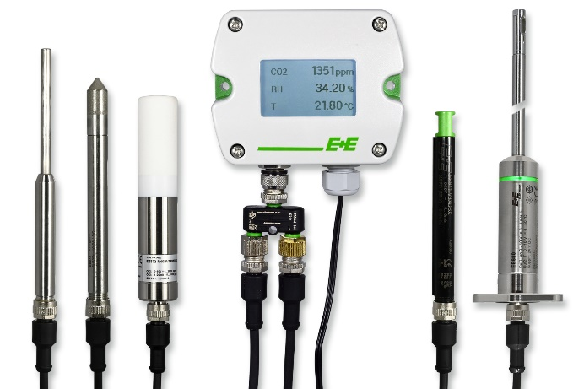

Sigma 05: The modular sensor platform by E+E Elektronik.

Photos: E+E Elektronik Ges.m.b.H., reprint free of charge

Company Profile
E+E Elektronik develops and manufactures sensors and transmitters for humidity, dew point, moisture in oil, CO₂, air velocity, flow, temperature and pressure. Hand-held meters, humidity calibration systems and calibration services complete the comprehensive product portfolio of the Austrian sensor specialist. The main applications for E+E products lie in HVAC, building automation, industrial process control and the automotive industry. A certified quality management system according to ISO 9001 and IATF 16949 ensures the highest quality standards. E+E Elektronik is represented with own subsidiaries in China, Germany, France, Italy, Korea, USA and sales partners in more than 60 countries worldwide. The accredited E+E calibration laboratory has been commissioned by the Austrian Federal Office for Metrology (BEV) to provide the national standards for humidity, dew point and air velocity.

E+E Elektronik Ges.m.b.H.
Langwiesen 7
4209 Engerwitzdorf
Austria
T: +43 (0) 7235 605-0
F: +43 (0) 7235 605-8
info@epluse.com
www.epluse.com

Press contact:
Mr. Johannes Fraundorfer
T: +43 (0)7235 605-217
pr@epluse.at

