Press Release

HTE & TEE301 Expand Sensing Element Series for Humidity and Temperature
The new HTE301 and TEE301 models see E+E Elektronik expand its digital sensing element portfolio to include two cost-optimised product variants.
(Engerwitzdorf, 20.9.2022) Austrian sensor manufacturer E+E Elektronik is expanding its digital sensing element portfolio to include two new product variants. The HTE301 humidity and temperature sensing element and the TEE301 temperature sensing element offer excellent measurement accuracy and a wide application temperature range from -40 °C to 125 °C (-40 °F to 257 °F). The small 8-pin DFN package with its I²C interface and four individually configurable I²C addresses is ideal for state-of-the-art, demanding designs.
The HTE and TEE301 sensing elements are part of the new sensing element generation by E+E Elektronik. Offering the same accuracy values, they are cost-optimised variants of the HTE and TEE501 sensing elements introduced earlier this year. With a different data format (16-bit unsigned integer) and pin assignment compared to the 501 series, the 301 series allows easy upgrade of existing applications with minimal integration effort.

HTE301 humidity and temperature sensing element
The HTE301 sensing element impresses with a measurement accuracy of up to ±1.8% RH (incl. hysteresis) and ±0.2 °C. It features an integrated constant current heater which keeps the element at approx. 2-3 °C over-temperature and prevents condensation forming on the sensing element. This results in excellent measurement performance and fast response time even in conditions with high humidity. On top of this, the proprietary E+E sensor coating protects the active sensor surface of the HTE301 against contamination and corrosive deposits.

TEE301 temperature sensing element
The TEE301 sensing element measures the temperature with an accuracy of up to ±0.2 °C. Thanks to its wide temperature range, the sensing element is versatile, providing a reliable and cost-effective solution for demanding temperature measurement tasks.

DFN package with I²C interface
Both sensing elements are available as an 8-pin DFN package with dimensions of just 2.5 x 2.5 x 0.9 mm³ to support easy integration into existing applications. The I²C interface enables robust data communication, supporting communication speeds up to 1,000 kHz. The sensing elements offer four selectable I²C addresses as well as alert and reset functions.

Characters (incl. spaces): 2433
Words: 362

Images
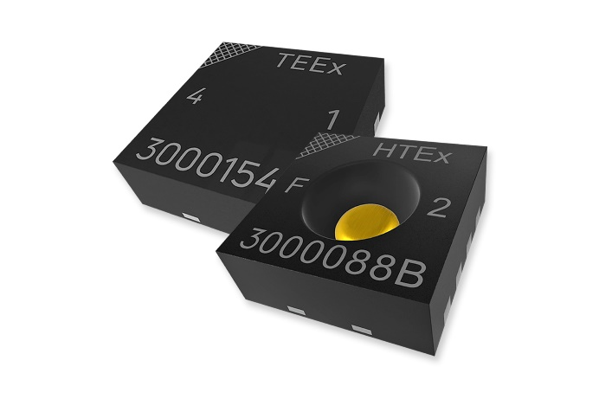
HTE301 and TEE301, the new humidity and temperature sensing elements from E+E Elektronik.

Photos: E+E Elektronik Ges.m.b.H., reprinting free of charge

Company profile
E+E Elektronik develops and produces sensing elements, modules and sensors for humidity, dew point, moisture in oil, CO₂, air velocity, flow, temperature and pressure. Hand-held meters, humidity calibration systems and calibration services complete the comprehensive product portfolio of the Austrian sensor specialist. The main applications for E+E products lie in HVAC, building automation, industrial process control and the automotive industry. A certified quality management system according to ISO 9001 and IATF 16949 ensures the highest quality standards. E+E Elektronik is represented by its own subsidiaries in China, France, Germany, India, Italy, Korea, USA and by sales partners in more than 60 countries worldwide. The accredited E+E calibration laboratory has been commissioned by the Austrian Federal Office of Metrology and Surveying (BEV) to provide the national standards for humidity, dew point, air velocity and gas concentration CO₂.
E+E Elektronik Ges.m.b.H.
Langwiesen 7
4209 Engerwitzdorf
Austria
T +43 7235 605-0
info@epluse.com
www.epluse.com

Press contact
Mr. Johannes Fraundorfer
T +43 7235 605-217
pr@epluse.com

