Press Release

Digital Sensing Element for High-Precision Humidity and Temperature Measurement
The HTE501 sensing element is suitable for particularly demanding measurement tasks thanks to its high level of accuracy, proven sensor protection and constant current heater.
(Engerwitzdorf, 18.01.2022) The digital humidity and temperature sensing element HTE501 from E+E Elektronik offers an excellent measurement accuracy of up to ±1.8 % RH incl. hysteresis and ±0.2 °C. The proven E+E sensor coating and the integrated constant current heater ensure a high level of reliability and durability of the sensing element even in harsh, dirty and condensing environments. The DFN enclosure, which measures just 2.5 x 2.5 x 0.9 mm, and the I²C interface enable simple design-in. The sensing element's diverse applications range from industrial and facility automation to medical technology, household electronics, smart and wearable devices.

High level of measurement accuracy, wide range of applications
The HTE501's high level of measurement accuracy is the result of the Austrian sensor specialist's more than 30 years of experience in the field of humidity measurement technology and the use of state-of-the-art manufacturing technologies. The stated accuracy of the relative humidity measurement of up to ±1.8 % includes hysteresis. Integrated hysteresis compensation ensures that the sensing element always keeps within its tolerance window, even when the humidity content rises or falls. With a temperature range of -40 °C to 135 °C, the HTE501 sensing element is suitable for a wide range of applications.
Suitable for demanding operating conditions
The HTE501's active sensor surface is permanently protected against dirt and corrosive deposits by the proprietary E+E sensor coating, which has proven itself over many years. Originally developed for industrial applications, this special protective coating ensures excellent measurement performance and long-term stability even under demanding conditions. The sensing element can therefore be used in harsh environments without the need for additional protection options such as a membrane filter or filter caps.
The integrated constant current heater, which can be activated as required, keeps the sensing element at excess temperature and thus prevents condensation and deposits caused by condensation.

Direct measured value output via I²C interface
The measured value output is based on the I²C data communication protocol. The measured values are available in 16 bit integer format and can be processed directly. In addition to the humidity and temperature values, the dew point is also calculated and output directly. It is not necessary to convert the measured values. 8 individually adjustable I²C addresses make it possible to operate several sensing elements on one I²C bus.

Simple design-in
The DFN enclosure of the HTE501 measures only 2.5 x 2.5 x 0.9 mm. This makes the sensing element suitable for demanding designs and tight spaces. The integrated I²C pull-up resistors further facilitate design-in, as no external circuitry is required.

Characters (incl. spaces): 3081
Words: 457

Images
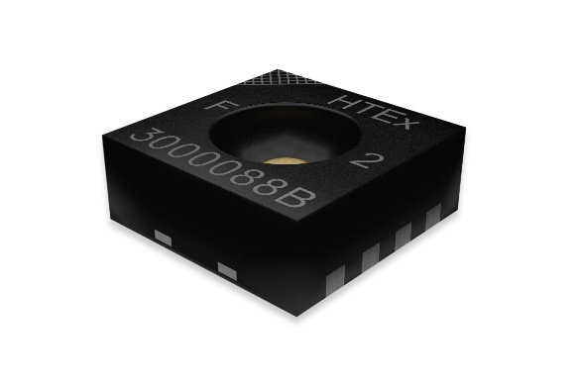
New HTE501 humidity and temperature sensing element from E+E Elektronik

Photos: E+E Elektronik Ges.m.b.H., reprinting free of charge

Company Profile
E+E Elektronik develops and manufactures sensors and transmitters for humidity, dew point, moisture in oil, CO₂, air velocity, flow, temperature and pressure. Hand-held meters, humidity calibration systems and calibration services complete the comprehensive product portfolio of the Austrian sensor specialist. The main applications for E+E products lie in HVAC, building automation, industrial process control and the automotive industry. A certified quality management system according to ISO 9001 and IATF 16949 ensures the highest quality standards. E+E Elektronik is represented with own subsidiaries in China, Germany, France, Italy, Korea, USA and sales partners in more than 60 countries worldwide. The accredited E+E calibration laboratory has been commissioned by the Austrian Federal Office for Metrology (BEV) to provide the national standards for humidity, dew point, air velocity and gas concentration CO₂.

E+E Elektronik Ges.m.b.H.
Langwiesen 7
4209 Engerwitzdorf
Austria
T +43 7235 605-0
info@epluse.com
www.epluse.com

Press contact
Mr. Johannes Fraundorfer
T +43 7235 605-217
pr@epluse.at

