Press Release

Digital Sensing Module for Cost-efficient Humidity and Temperature Measurement
The HTM502 sensing module makes it possible to achieve precise humidity and temperature measurement without major integration effort.
(Engerwitzdorf, 12.10.2022) The HTM502 sensing module by Austrian sensor manufacturer E+E Elektronik offers a cost-effective solution for humidity and temperature measurement. It is characterised by easy implementation, high accuracy and reliability. Integration and interchangeability via the I²C interface allow for rapid project implementation. The integrated sensor protection and the mechanically robust enclosure support a wide range of applications. The module is particularly suitable for price-sensitive applications in the HVAC sector but also for industrial applications.

Excellent measurement accuracy, robust design
The HTM502 sensing module measures humidity and temperature with an accuracy of ±2.0% RH and ±0.3 °C (0.54 °F) and can be used in applications between 5 °C and 60 °C (41...140 °F). The robust enclosure gives the module great mechanical stability and ensures ease of handling by preventing accidental contact with the sensing element. The integrated E+E sensor coating protects the sensing element against dirt and corrosion, improving measurement performance and long-term stability in harsh and demanding environments.

Rapid integration via I²C
The I²C interface allows for easy integration of the humidity and temperature module, meaning that projects can be quickly implemented. The HTM502 offers two measurement operating modes (single-shot or periodic measurement mode) and supports communication speeds up to 1000 kHz. Thanks to the low supply voltage of 2.35 – 3.60 V and the low current requirement, the module is also suitable for applications with low energy consumption.

Easy installation and replacement
The HTM502's design lends itself to easy installation without additional implementation overhead or soldering work. Thanks to the 4-pin connector plug, the sensing module can quickly be replaced in the field.

Characters (incl. spaces): 2058
Words: 291

Images
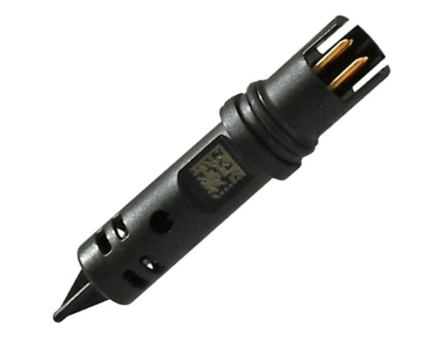
HTM502 digital sensing module for humidity and temperature

Photos: E+E Elektronik Ges.m.b.H., reprinting free of charge

Company profile
E+E Elektronik develops and produces sensing elements, modules and sensors for humidity, dew point, moisture in oil, CO₂, air velocity, flow, temperature and pressure. Hand-held meters, humidity calibration systems and calibration services complete the comprehensive product portfolio of the Austrian sensor specialist. The main applications for E+E products lie in HVAC, building automation, industrial process control and the automotive industry. A certified quality management system according to ISO 9001 and IATF 16949 ensures the highest quality standards. E+E Elektronik is represented by its own subsidiaries in China, France, Germany, India, Italy, Korea, USA and by sales partners in more than 60 countries worldwide. The accredited E+E calibration laboratory has been commissioned by the Austrian Federal Office of Metrology and Surveying (BEV) to provide the national standards for humidity, dew point, air velocity and gas concentration CO₂.
E+E Elektronik Ges.m.b.H.
Langwiesen 7
4209 Engerwitzdorf
Austria
T +43 7235 605-0
info@epluse.com
www.epluse.com

Press contact
Mr. Johannes Fraundorfer
T +43 7235 605-217
pr@epluse.com

