Press Release

Precise Humidity and Temperature Probe for Drying Processes
The HTP501 digital humidity and temperature probe is optimised for harsh environmental conditions and suitable for temperatures up to 120 °C (248 °F).
(Engerwitzdorf, 12.05.2022) The HTP501 humidity and temperature probe by E+E Elektronik is designed for use in drying chambers and other demanding industrial applications. The stainless steel probe offers excellent measurement accuracy and can be deployed in temperatures ranging from -40 to 120 °C (-40 to 248 °F). The measured values are available on the RS485 interface with Modbus RTU protocol.

Optimised for harsh environmental conditions
The HTP501 features a rugged IP66 stainless steel enclosure, a high-temperature cable with moulded M12 connector, and a choice of different filter caps. The electronics are well protected inside the probe and therefore safe from condensation and corrosion. The E+E proprietary coating protects the humidity sensing element and its leads against dust and corrosive deposits, ensuring excellent measuring performance and long-term stability in harsh conditions. An optional sensor leads protection helps to significantly extend the service life of the sensing element in particularly aggressive environments.

High measurement accuracy, easy data integration
The HTP501 measures the relative humidity and temperature in an operating range of -40 to 120 °C (-40 to 248 °F). The high-quality E+E humidity sensing element, temperature compensation and configurable pressure compensation ensure excellent measurement accuracy.
In addition to the measured humidity and temperature values, the sensing probe calculates further humidity-related physical quantities such as the dew point temperature, absolute humidity or mixing ratio.
The measured data are available on the RS485 interface and can be easily integrated into process control using the Modbus RTU protocol.

Flexible and extensible
Two probe lengths (200 mm and 400 mm) and three different cable lengths offer the user a huge degree of flexibility when installing the HTP501. The free PCS10 configuration software facilitates the setup and supports individual configuration of the probe.
The HTP501 is compatible with the Sigma 05 sensor hub by E+E Elektronik. The digital sensing probe can be plugged into the host device based on the plug-and-play principle and thus extended to a sensor unit with display and analogue outputs.

Characters (incl. blanks): 2431
Words: 358

Images
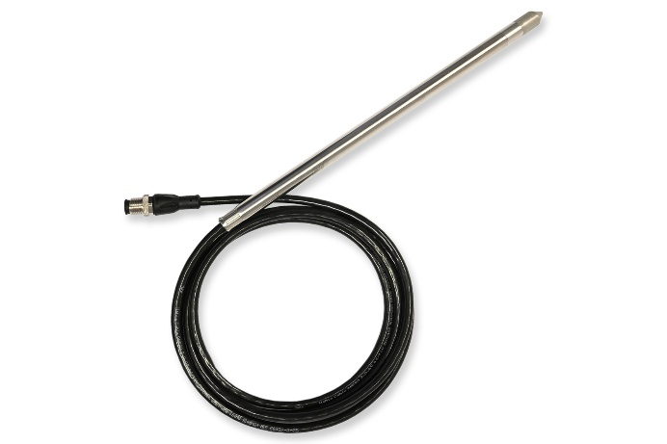
HTP501 humidity and temperature probe with RS485 interface

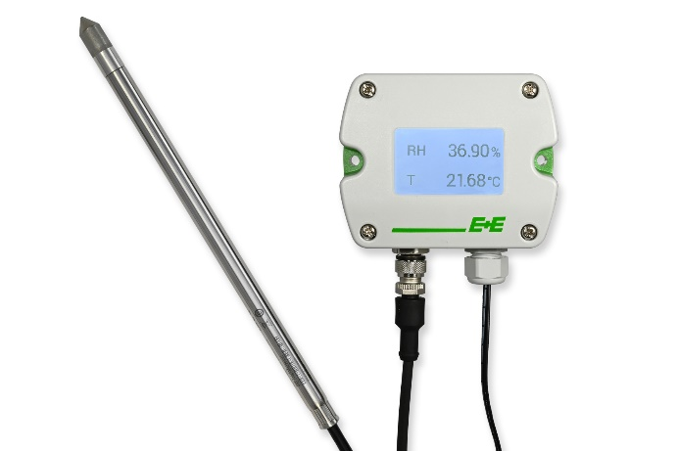
The HTP501 is compatible with the Sigma 05 sensor hub

Photos: E+E Elektronik Ges.m.b.H., reprinting free of charge

Company profile
E+E Elektronik develops and produces sensing elements, modules and sensors for humidity, dew point, moisture in oil, CO₂, air velocity, flow, temperature and pressure. Hand-held meters, humidity calibration systems and calibration services complete the comprehensive product portfolio of the Austrian sensor specialist. The main applications for E+E products lie in HVAC, building automation, industrial process control and the automotive industry. A certified quality management system according to ISO 9001 and IATF 16949 ensures the highest quality standards. E+E Elektronik is represented by its own subsidiaries in China, France, Germany, India, Italy, Korea, USA and by sales partners in more than 60 countries worldwide. The accredited E+E calibration laboratory has been commissioned by the Austrian Federal Office of Metrology and Surveying (BEV) to provide the national standards for humidity, dew point, air velocity and gas concentration CO₂.
E+E Elektronik Ges.m.b.H.
Langwiesen 7
4209 Engerwitzdorf
Austria
T +43 7235 605-0
info@epluse.com
www.epluse.com

Press contact
Mr. Johannes Fraundorfer
T +43 7235 605-217
pr@epluse.at

