Press Release

Digital Immersion Probe for Determining Moisture in Oil
The MOP301 moisture in oil probe enables reliable measurement of the water activity, temperature and absolute water content of various oils.
(Engerwitzdorf, 10.03.2022) The MOP301 immersion probe by E+E Elektronik precisely measures the moisture in transformer, lubrication or hydraulic oils as well as diesel fuel. It is used for preventive maintenance of equipment and machinery. The stainless steel probe can be used in oils up to 120 °C (248 °F) and 20 bar pressure. The measured data for water activity, temperature and absolute water content are available via the RS485 interface with Modbus RTU protocol.

Excellent measuring performance, rugged design
The E+E humidity sensing elements used in the MOP301 are characterised by their long-term stability and resistance to contamination. They form the basis for high-precision and reliable humidity and temperature measurement.
The immersion probe is impressive mechanically with a rugged stainless steel enclosure with protection class IP66, an oil-resistant cable and a moulded M12 connector. It can be used in a temperature range of -40 to 120 °C (-40...248 °F) and at up to 20 bar pressure.
Various probe and cable lengths and the lean design enable particularly flexible installation of the MOP301. Thanks to the practical slide fitting, the immersion depth can be precisely set, and changed if needed. Using an optional ball valve, the probe can be installed and removed without interrupting the process and under pressure.

Measured values an interfaces
The MOP301 delivers the oil moisture content as an absolute or relative value. The water activity (a_{w}) states the relative moisture content of an oil and describes the relationship between the actual and maximum possible amount of dissolved water. The a_{w} value reveals how close the oil is to the saturation point at a specific temperature.
The water content (x) expresses the moisture content in absolute figures. It is stated in ppm or mg water / kg oil. The MOP301 calculates the water content based on the measured water activity and temperature. The oil-specific parameters required for calculation can be factory pre-configured, written via Modbus RTU, or set retroactively with the aid of the PCS10 Product Configuration Software.
The measured values are provided via the RS485 interface using the Modbus RTU protocol.

Extensible to a sensor unit
The MOP301 is compatible with the Sigma 05 sensor hub by E+E Elektronik. The probe can be plugged into the host device based on the plug-and-play principle and thus extended to a sensor unit with analogue outputs and an optional display.

Characters (incl. spaces): 2654
Words: 419

Images
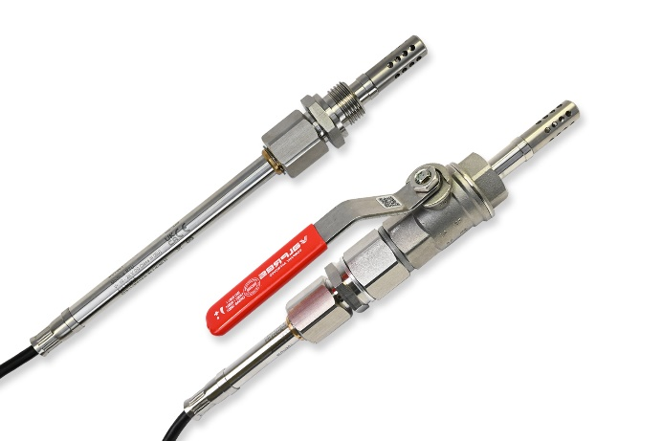
MOP301 moisture in oil probe: the immersion probe can be installed directly with a slide fitting or also using a ball valve

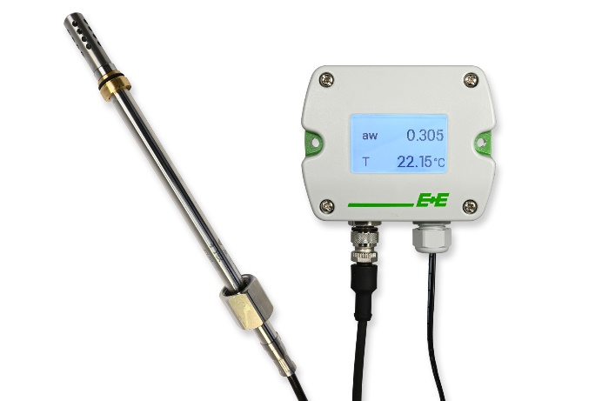
The MOP301 is compatible with the Sigma 05 sensor hub

Photos: E+E Elektronik Ges.m.b.H., reprinting free of charge

Company profile
E+E Elektronik develops and produces sensing elements, modules and sensors for humidity, dew point, moisture in oil, CO₂, air velocity, flow, temperature and pressure. Hand-held meters, humidity calibration systems and calibration services complete the comprehensive product portfolio of the Austrian sensor specialist. The main applications for E+E products lie in HVAC, building automation, industrial process control and the automotive industry. A certified quality management system according to ISO 9001 and IATF 16949 ensures the highest quality standards. E+E Elektronik is represented by its own subsidiaries in China, France, Germany, India, Italy, Korea, USA and by sales partners in more than 60 countries worldwide. The accredited E+E calibration laboratory has been commissioned by the Austrian Federal Office of Metrology and Surveying (BEV) to provide the national standards for humidity, dew point, air velocity and gas concentration CO₂.
E+E Elektronik Ges.m.b.H.
Langwiesen 7
4209 Engerwitzdorf
Austria
T +43 7235 605-0
info@epluse.com
www.epluse.com

Press contact
Mr. Johannes Fraundorfer
T +43 7235 605-217
pr@epluse.at

